**MANAGED TABLES AND UNMANAGED TABLES**

**MANAGED TABLES:**

• **Definition**: Spark manages both the table's metadata and the actual data.

* **Storage Location**: Data is stored in the default warehouse directory (e.g., /user/hive/warehouse).
* **Lifecycle**: Dropping the table deletes both the metadata and the data.
* **Use Case**: Ideal when Spark should fully control the data lifecycle.

Example code of managed tables

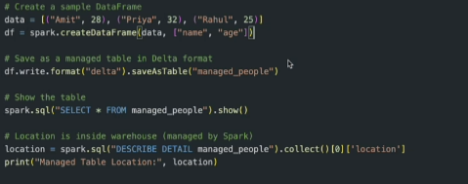

**Unmanaged tables:**

• Definition: Spark manages only the metadata; the data resides in a user-specified location.

Storage Location: You define the path using the LOCATION clause.

Lifecycle: Dropping the table deletes only the metadata; the data remains intact.

Use Case: Useful when data is shared across multiple tools or systems

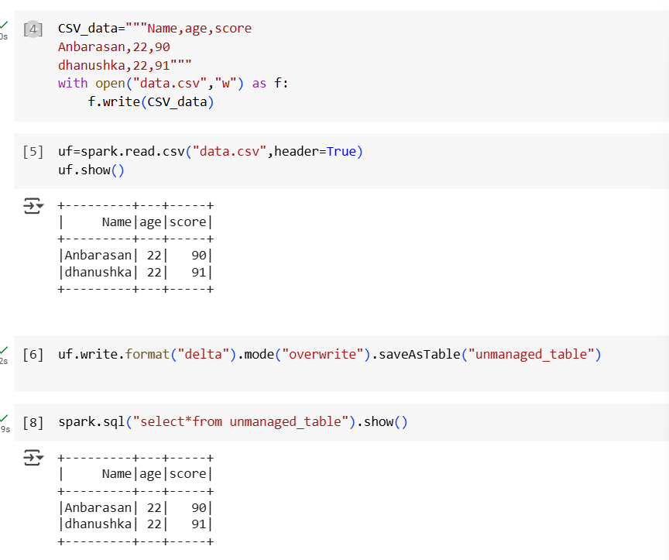

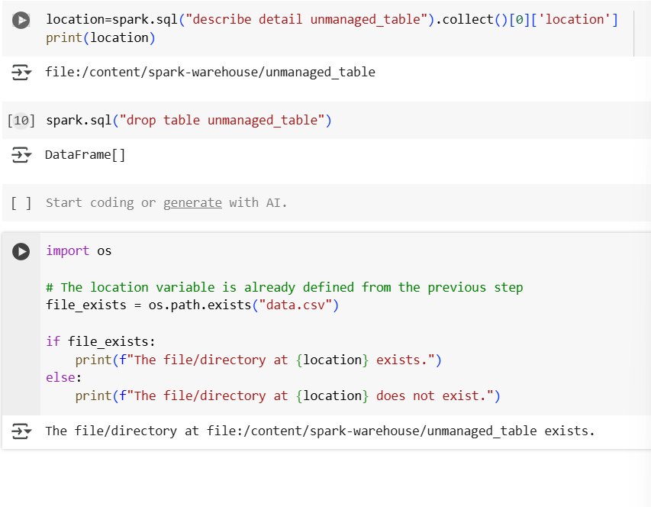

**Pipeline:**